REPORT
MACHINE LEARNING MODEL DEVELOPMENT AND EVALUATION
Customer Churn Prediction using Python and Scikit-learn

1. Executive Summary
This project develops a binary classification model to estimate whether a customer will churn. The supplied workflow loads a 10,000-row customer dataset, cleans missing values, explores churn patterns, and trains multiple classifiers. The final selected approach is a class-weighted Logistic Regression pipeline with a probability threshold of 0.60 chosen on a validation set by F1 score.
On the held-out test set of 2,000 customers, the selected model achieved 76.6% accuracy, 48.6% precision, 60.2% recall, an F1 score of 0.5375, and ROC-AUC of 0.7879. It detected 272 of 452 churners, while missing 180 churners and generating 288 false alarms. The model is useful as a prioritization aid, but its precision means that retention teams should not treat every flagged customer as certain to leave.

2. Objective and Problem Definition
The objective is to build and evaluate a model that predicts the binary target Churn (1 = churn, 0 = retained) from customer profile, contract, service, usage, billing, satisfaction, complaint, and support variables. Predicted probabilities are also converted into low-, medium-, and high-risk categories to support customer-retention planning.

3.Dataset Overview
The notebook loads a dataset with 10,000 records and 16 original columns. Customer_ID is an identifier rather than a predictive feature; it is excluded from X. The target distribution is 7,740 retained customers (77.4%) and 2,260 churned customers (22.6%), so the classes are imbalanced.
Item | Notebook finding | Implication
Rows | 10,000 | Sufficient for a baseline split-based experiment
Original columns | 16 | 15 predictors/ID plus target; ID removed from features
Target prevalence | 22.6% churn; 77.4% retained | Accuracy alone can conceal poor churn detection
Missing values | 50 Payment_Method; 100 Total_Charges; 100 Satisfaction_Score | Imputation required before training
Duplicates | 0 duplicate rows; 0 duplicate Customer_ID values | No duplicates reported in initial checks

4. Data Cleaning and Exploratory Analysis
The notebook checks data types, missingness, duplicated rows, duplicated customer identifiers, descriptive statistics, and the target distribution. Missing values reported included 50 Payment_Method entries (0.5%) and 100 Total_Charges entries (1.0%); Satisfaction_Score was also filled using its median, indicating missingness in that field,
filled Payment_Method with its mode and Total_Charges and Satisfaction_Score with their medians. The notebook then reported no missing values.Removed exploratory-only derived grouping columns before modelling. Dropped Churn from X and dropped Customer_ID because it is an identifier, not a meaningful predictive feature.

5. Feature Preparation and Data Splitting
The notebook separates y = Churn and X = all remaining columns except Customer_ID. It creates categorical and numerical feature lists from data types. Numerical variables are standardized with StandardScaler; categorical variables are one-hot encoded with OneHotEncoder(handle_unknown='ignore'). A ColumnTransformer combines these operations inside a Scikit-learn Pipeline so preprocessing is applied consistently during fitting and prediction.
An initial stratified train/test split reserves 20% (8,000 training rows and 2,000 test rows), with random_state=42. For the final threshold-selection workflow, the training portion is split again into 6,400 rows for model fitting and 1,600 validation rows. The 2,000-row test set is kept for final evaluation.

6. Algorithm Selection and Justification
Logistic Regression is a suitable baseline because the task is binary classification, its coefficients are relatively interpretable, and predict_proba provides churn-risk estimates. The balanced version sets class_weight='balanced' to give more weight to the minority churn class. Random Forest is included as a non-linear comparison model that can capture interactions, though the notebook results show lower churn recall for that configuration.
The final pipeline uses LogisticRegression(max_iter=1000, class_weight='balanced', random_state=42). The validation set is used to compare thresholds from 0.30 to 0.70. Threshold 0.60 yields the highest validation F1-score in the recorded threshold table (about 0.587), balancing precision and recall better than the other tested values.

Models Developed

Logistic Regression
Logistic Regression was used as a baseline classification model. It produced an accuracy of 0.80, precision of 0.63, recall of 0.33, F1-score of 0.43, and ROC-AUC of 0.79 in the notebook's initial evaluation. Its recall shows that the default classification approach missed many actual churners.

Class-Weighted Logistic Regression
Class weighting was applied to give greater importance to the minority churn class. In the initial balanced-model evaluation, recall increased to 0.71, while precision decreased to 0.41. This illustrates the trade-off between finding more churners and generating more false-positive alerts. A later validation workflow tuned the probability threshold and then evaluated the final model on the untouched test set.

Random Forest
A Random Forest classifier with 200 trees, class_weight='balanced', and random_state=42 was also tested. The notebook recorded accuracy of 0.79, precision of 0.59, recall of 0.24, F1-score of 0.34, and ROC-AUC of 0.77 for this evaluation. Its recall was lower than the class-weighted Logistic Regression approach.

Model Comparison
Model / evaluation | Accuracy | Precision | Recall | F1-score | ROC-AUC
Logistic Regression (baseline) | 0.800 | 0.630 | 0.330 | 0.430 | 0.790
Class-weighted Logistic Regression (initial) | 0.710 | 0.410 | 0.710 | 0.520 | 0.790
Random Forest | 0.790 | 0.590 | 0.240 | 0.340 | 0.770
Final tuned class-weighted Logistic Regression | 0.766 | 0.486 | 0.602 | 0.538 | 0.788

The standard Logistic Regression model has the highest accuracy and precision among the reported comparisons, but only 33.0% recall. The balanced model improves recall to 60.2% and F1 to 0.538, making it a more suitable choice when missing a churner is costly. Its accuracy and precision are lower, showing the expected trade-off between catching more churners and raising more false alarms. The Random Forest comparison has the lowest recall (24.0%) and F1 score (0.340) in the reported table
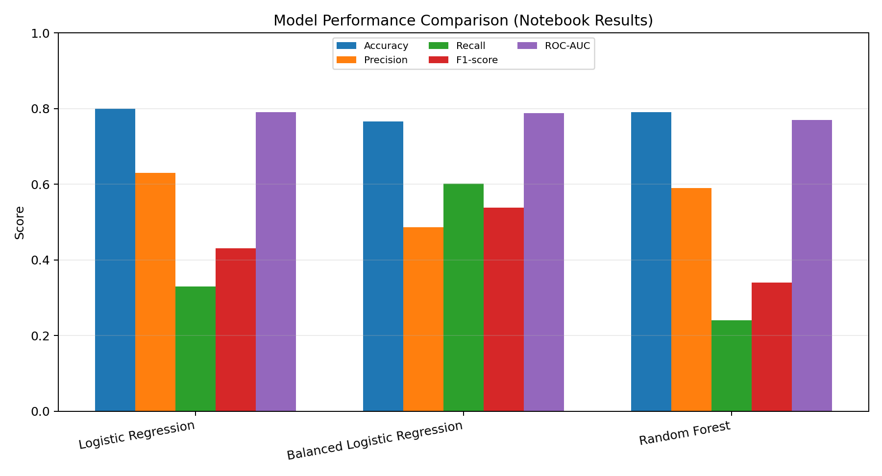

7. Confusion Matrix and Error Analysis.

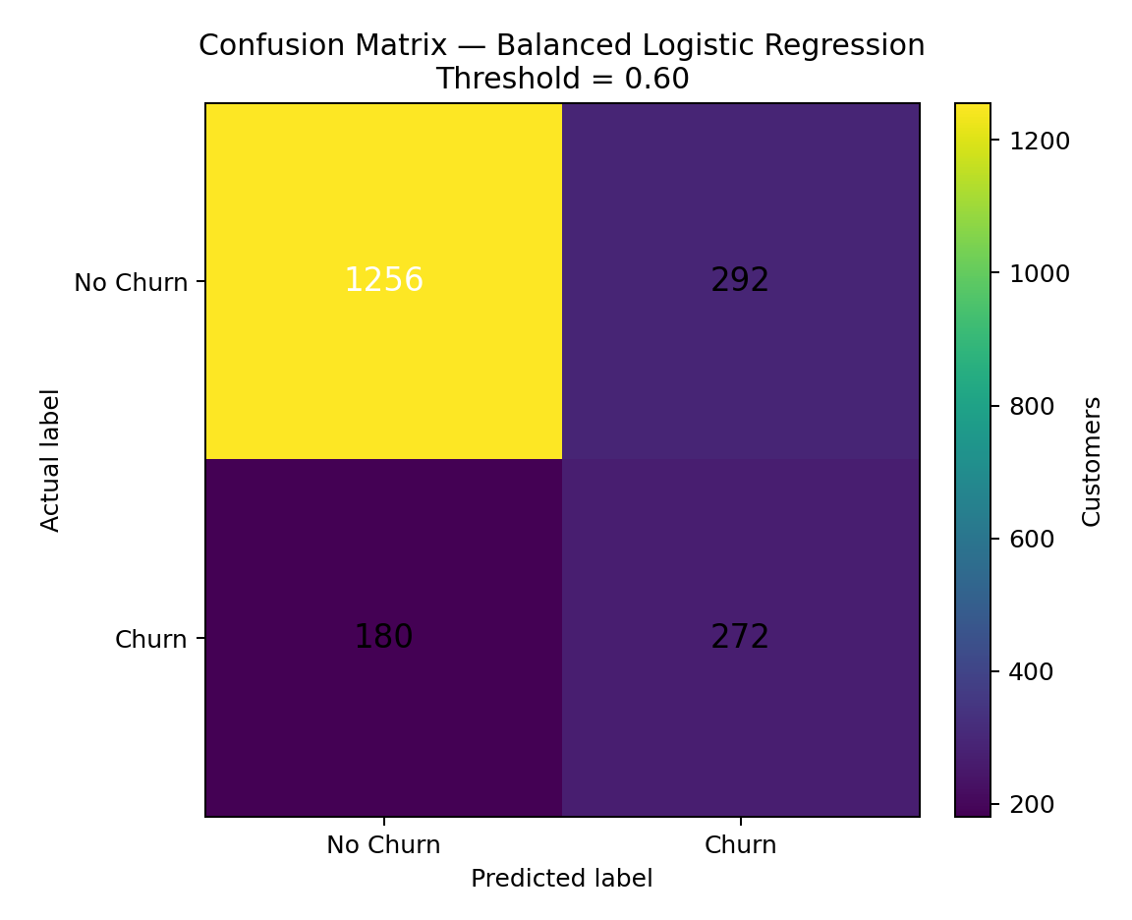
The threshold-0.60 evaluation of the balanced Logistic Regression reports the confusion matrix below: 1,256 true negatives, 292 false positives, 180 false negatives, and 272 true positives. This corresponds to identifying 272 of 452 actual churners (about 60% recall), while 292 retained customers are incorrectly flagged as churn risks. The counts are from the notebook's earlier balanced-model threshold evaluation; the later refitted final pipeline reports rounded metrics of 0.77 accuracy, 0.49 precision, 0.60 recall, 0.54 F1-score, and 0.79 ROC-AUC. Minor differences can occur between those notebook evaluation stages.

8. Threshold Tuning
Threshold selection changes the operational balance between precision and recall. Lower thresholds capture more churners but produce more false positives; higher thresholds reduce false positives but miss more churners. The validation results show the highest tested F1 score at threshold 0.60 (precision 0.531, recall 0.655, F1 0.587). The final test metrics differ slightly, as expected, because they are measured on separate unseen data.

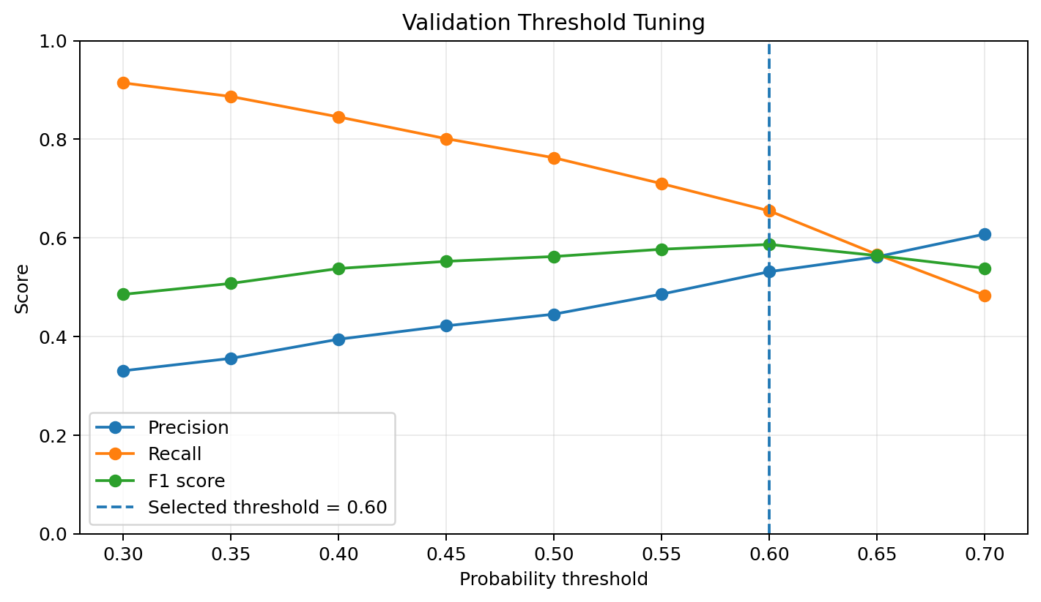

Threshold | Precision | Recall | F1-score
0.50 | 0.445 | 0.762 | 0.562
0.55 | 0.486 | 0.710 | 0.577
0.60 (selected) | 0.531 | 0.655 | 0.587
0.65 | 0.562 | 0.566 | 0.564
0.70 | 0.608 | 0.483 | 0.538

Final Test-Set Evaluation
Metric | Final value | Meaning
Accuracy | 0.77 | About 77% of all test records were classified correctly.
Precision (Churn) | 0.49 | About 49% of customers predicted to churn actually churned.
Recall (Churn) | 0.60 | The model identified about 60% of actual churners.
F1-score (Churn) | 0.54 | Balance between churn precision and recall.
ROC-AUC | 0.79 | The model has useful ability to distinguish churn and non-churn cases across thresholds.

10. Customer Risk Segmentation and Practical Use
The notebook categorizes risk using predicted probability: High Risk at 0.70 or above, Medium Risk at 0.40 to below 0.70, and Low Risk below 0.40. In the 2,000-customer test output, the reported groups are 366 high-risk, 641 medium-risk, and 993 low-risk customers. Their observed churn rates are about 53.8%, 27.0%, and 8.3%, respectively. The notebook also generates rule-based risk reasons and suggested retention actions, such as contract incentives or service/satisfaction follow-up. These explanations are heuristic rules, not causal explanations produced by the model.
11. Potential Sources of Error and Limitations
Class imbalance: only 22.6% of records are churn cases. Accuracy can overstate usefulness, so precision, recall, F1, PR-AUC, and the confusion matrix should be monitored.
False positives: at the selected threshold, a substantial number of customers are flagged who do not churn. Retention campaigns should consider their cost and customer experience.
False negatives: around 40% of actual churners are missed at roughly 60% recall, leaving room to improve early-warning coverage.
Imputation assumptions: mode/median imputation is simple and may suppress meaningful patterns in missingness. Fit imputation only on training data inside the pipeline for a production-grade workflow.
Data leakage risk: the notebook imputes missing values before the split, and feature-engineered group columns may be included alongside their source variables. This should be reviewed; all learned preprocessing should be fitted using training data only.
Threshold/test-set consistency: the later workflow uses a validation set to select the threshold, which is good practice. The earlier notebook also explores thresholds on test probabilities; those exploratory results should not be used to claim unbiased final test performance.
Overfitting/underfitting: a single split does not establish generalization stability. Logistic Regression may underfit complex relationships; Random Forest may overfit depending on depth and leaf settings. Compare train and validation performance and use cross-validation.
Interpretability: logistic coefficients indicate conditional associations on the encoded/scaled data, not causation. Rule-based risk reasons are hand-crafted and may not match the model's strongest signals.
Dataset representativeness and drift: the notebook does not document data provenance, observation period, or whether the sample reflects future customers. Performance can change over time.

12. Recommendations for Improvement
Use a fully leakage-safe preprocessing pipeline, including SimpleImputer for missing values, fitted only on each training fold.
Evaluate with stratified cross-validation and report mean and variation for F1, recall, ROC-AUC, and especially precision-recall AUC.
Plot the ROC curve and precision-recall curve from held-out predictions; the notebook contains ROC-AUC values but no clearly recorded ROC curve figure.
Select the threshold using business costs (retention budget, campaign success rate, and cost of missed churn) in addition to F1-score.
Calibrate predicted probabilities (for example, calibration curve or calibrated classifier) before interpreting them as real-world churn likelihoods.
Tune Random Forest hyperparameters and consider gradient boosting; compare against Logistic Regression using the same folds and evaluation protocol.
Inspect feature importance and coefficient stability, and validate whether high-risk reasons are accurate and actionable with domain experts.
Monitor drift and performance after deployment, and run controlled retention experiments to test whether interventions actually reduce churn.

13. Conclusion
The notebook completes workflow: data inspection and cleaning, exploratory analysis, feature preparation, stratified train/test splitting, pipeline-based model training, comparison of three classifiers, validation-based threshold selection, test evaluation, and customer-level risk scoring. Balanced Logistic Regression is the preferred baseline when churn detection is prioritized because it substantially improves recall and F1-score over the unweighted baseline. However, its moderate precision and remaining false negatives mean it should support—not replace—business judgment. More robust cross-validation, leakage-safe imputation, cost-sensitive thresholding, and ongoing monitoring are the most important next steps.

